AnalytiXVector

## Social Media Dashboard Application

# The Ministry of Communications and Information Technology

## Digital Egypt Pioneers Initiative (DEPI) Program

## React Web Development Track Final Project

## Phase 2 2025

# Team Members

|  |  |  |
| --- | --- | --- |
| Name | Email | Group Code |
| Yehia Abdelhady | Ye7iaabdelhady@gmail.com | YAT367B |
| Ahmed Hany | ahmedhay.22@hotmail.com | YAT367B |
| hajar ibrahim | hajaribrahim285@gmail.com | YAT367B |
| Mohamed Adel | mohamed.adele097@gmail.com | YAT367B |

# Project Manager

## Eng. Ashraf Sadek

# Table Of Content

Social Media Dashboard Application 0

The Ministry of Communications and Information Technology 0

Digital Egypt Pioneers Initiative (DEPI) Program 0

React Web Development Track Final Project 0

Phase 2 2025 0

Team Members 0

Project Manager 0

Eng. Ashraf Sadek 0

Table Of Content 1

1. Project Planning & Management 2

1.1. Project Proposal 2

1.1.1. Overview 2

1.1.2. Objective 2

1.1.3. Scope 3

1.2. Project Plan 3

1.2.1. Timeline 3

1.2.2. Milestones and Deliverables 4

1.2.3. Task Assignment and Roles 4

2. Review of Literature 5

3. Requirements Gathering 7

3.1. Stakeholder Analysis 7

3.2. User Stories and Use Cases 7

3.2.1. User Stories 7

3.2.2. Use Cases 8

3.3. Functional Requirements 9

3.4. Non-Functional Requirements 10

4. System Analysis and Design 11

4.1 Data Flow & System Behaviour 11

4.2 Sequence Diagram 12

4.3 Activity Diagram 12

4.3 State Diagram 13

5.1 Wireframes and Mock-ups 14

6.1. Technology Stack 17

6.2. Deployment Diagram 17

6.3. Component Diagram 18

Document Complete 18

# Project Planning & Management

## Project Proposal

## Overview

The social media dashboard is designed to provide real-time insights and analytics for monitoring activity across multiple social media platforms. This dashboard will serve as a centralized hub for tracking key metrics, engagement trends, and content performance, helping businesses, marketers, and influencers make data-driven decisions.

**Supported Platforms:**

* **Facebook**
* **YouTube**
* **Instagram**
* **TikTok**

The dashboard will integrate with APIs from these platforms to fetch and display live data, ensuring users have up-to-date information on their social media performance. By offering real-time analytics, the system aims to enhance social media strategy, optimize engagement, and provide valuable insights for content creators and businesses.

## Objective

The main objective of the social media dashboard is to:

* Provide real-time updates on social media accounts activity.
* Provide visualized analytics like charts, tables and graphs
* Improve decision-making for content strategies and marketing campaigns.
* Monitor brand performance and reputation across multiple platforms.
* Enhance audience engagement by analysing interaction trends

## Scope

The social media dashboard will cover the following aspects:

* **Data Collection & Integration**: Fetching data from various social media APIs to ensure real-time insights.
* **Real-Time Analytics & Visualization**: Displaying engagement metrics, audience growth, and content performance using graphs, charts, and tables.
* **User Authentication & Roles**: Implementing secure login and role-based access control for different user types.
* **Automated Alerts & Notifications**: Sending real-time notifications for significant engagement spikes, mentions, or trends.
* **Customization & Filters**: Allowing users to filter and customize their dashboard based on specific KPIs, timeframes, and platforms.
* **Responsive & Intuitive UI**: Designing a user-friendly interface optimized for various devices, including desktops, tablets, and smartphones.

## Project Plan

## TimelineA screenshot of a computer

## Milestones and Deliverables

|  |  |  |
| --- | --- | --- |
| Milestone | Deliverables | Estimated Completion Date |
| Initial Setup and Planning | * Project setup with React, Nodejs and Redux * Wireframes for dashboard UI * Clear documentation of the backend API endpoints | 21 / 3 / 2025 |
| Implement Core Features | * Working frontend layout * Core dashboard components (charts, tables, graphs, etc..) * Functional API integration with real-time data | 28 / 3 / 2025 |
| Advanced Features and Testing | * Advanced features (sorting, filtering) * Unit tests for all components * Fully responsive and polished UI | 4 / 4 / 2025 |
| Final Touches and Documentation | * Deployed dashboard * Complete project documentation * Finalized, fully functional dashboard with social media analytics | 11 / 4 / 2025 |

## Task Assignment and Roles

|  |  |
| --- | --- |
| Team Member | Tasks |
| Ahmed Hany | * Data flow Diagram * Sequence Diagram * Activity Diagram * State Diagram * Technology Stack * Deployment Diagram * Component Diagram |
| Mohamed Adel | * Design UI layout, and screens * Design FIGMA screens for the application * Design of Wireframes and mock-up |
| Hajar Ibrahim | * Design UI layout, screens and final touches. * Design FIGMA screens for the application * Design of Wireframes and mock-ups |
| Yehia Abdelhady | * Project Proposal * Project Plan * Stake holder analysis * Use Cases * User Stories * Functional Requirements * Non-Functional Requirements |

# Review of Literature

The increasing reliance on social media analytics for marketing, brand monitoring, and audience engagement has led to the development of various real-time dashboard applications. This review examines existing literature and tools related to real-time social media analytics, highlighting their methodologies, capabilities, and limitations.

**1. Real-Time Analytics in Social Media**

Several studies emphasize the importance of **real-time data processing** in social media monitoring. According to Gandomi & Haider (2015), **big data analytics** in social media enables businesses to extract meaningful insights from large volumes of user-generated content. Real-time analytics, in particular, allows organizations to respond quickly to engagement trends and market shifts (Zeng et al., 2010).

**Key Findings:**

* Real-time analytics improves **decision-making speed** (Chen et al., 2012).
* **Predictive analytics** in social media can forecast engagement trends (Shmueli & Koppius, 2011).
* Sentiment analysis tools help businesses understand customer perceptions in real time (Medhat et al., 2014).

**2. Existing Social Media Dashboards**

Several commercial and open-source solutions provide social media analytics dashboards. Some well-known tools include:

* **Hootsuite** – Provides social media management and analytics but lacks real-time engagement tracking.
* **Sprout Social** – Offers analytics and reporting but has limitations in API integration flexibility.
* **Google Data Studio** – Supports data visualization but requires external connectors for social media platforms.
* **Brandwatch & Meltwater** – Specialize in sentiment analysis but are expensive for small businesses.

A comparison by Stieglitz et al. (2018) indicates that most existing platforms focus on **historical data aggregation** rather than real-time insights, creating a gap that a truly real-time dashboard can address.

**3. API Integration and Data Processing Challenges**

Integrating real-time data from platforms like Facebook, Instagram, YouTube, and TikTok presents significant **technical challenges** due to API rate limits, data privacy policies (GDPR, CCPA), and varying data structures. Studies by Hashem et al. (2015) highlight the importance of **cloud-based solutions** for handling large-scale real-time data streams efficiently.

**Challenges Identified:**

* **Rate-limited APIs**: Many platforms restrict data fetching frequency.
* **Data inconsistency**: Each platform has different engagement metrics and reporting structures.
* **Compliance and security**: Adhering to privacy laws while processing user-generated data.

**4. Visualization and User Experience in Dashboards**

User experience is a critical aspect of social media dashboards. Studies by Few (2006) emphasize the need for **clear, interactive visualizations** to make analytics actionable. Best practices in UI/UX for dashboards include:

* **Minimalist design** for reducing cognitive load.
* **Drill-down capabilities** for detailed metric analysis.
* **Customizable widgets** for personalized analytics views.

A study by Knaflic (2015) on data storytelling suggests that effective dashboards should combine **data visualization with narrative insights** to improve decision-making.

# Requirements Gathering

## Stakeholder Analysis

* **Project Sponsor**: The Ministry of Communications and Information Technology
* **Project Manager**:
* **End Users/Clients**: The social media dashboard is designed for a diverse range of users who rely on social media analytics to make informed decisions. The primary target audience includes:
* **Digital Marketers**: Professionals who need to track campaign performance, engagement trends, and audience insights.
* **Social Media Managers**: Individuals managing brand presence across multiple platforms and monitoring real-time interactions.
* **Content Creators & Influencers**: Users who need to analyze content performance, audience engagement, and optimize their posting strategies.
* **Businesses & Enterprises**: Organizations looking to track brand mentions, customer sentiment, and social media ROI.
* **Agencies & Consultants**: Marketing agencies and consultants who provide data-driven insights and strategies for clients.

## User Stories and Use Cases

There is only one role/actor for the social media analytics app, but this actor can have different goals and objectives, this actor can be categorized as following:

* Digital Marketer:
* Social Media Manager
* Business Owner
* Content Creator

Identifying the types of users will help improve achieving user needs and requirements.

## User Stories

* **As a User**, I want to securely log in and manage my account settings so that I can personalize my experience.
* **As a User**, I want to have a customizable dashboard layout so that I can focus on the metrics most relevant to me.
* **As a User**, I want to view real-time engagement metrics across multiple social media platforms so that I can assess campaign performance and adjust strategies accordingly.
* **As a User**, I want to receive automated alerts for engagement spikes and brand mentions so that I can respond promptly.
* **As a User**, I want to analyse audience interaction trends on my posts so that I can optimize my content strategy.
* **As a User**, I want to track brand sentiment and customer feedback in real-time so that I can make informed business decisions.
* **As a User,** I want to be able to search and filter results based on multiple criteria.

## Use Cases

1. **User Authentication**
   * Actors: User, Administrator
   * Description: The user logs in securely to access their personalized dashboard.
   * Precondition: User has valid credentials.
   * Postcondition: User is successfully authenticated and redirected to the dashboard.
2. **View Real-Time Analytics**
   * Actors: Digital Marketer, Social Media Manager, Content Creator
   * Description: The user accesses the dashboard to view live engagement metrics across social media platforms.
   * Precondition: User is logged in and has integrated social media accounts.
   * Postcondition: The dashboard displays real-time insights.
3. **Receive Automated Alerts**
   * Actors: Social Media Manager, Business Owner
   * Description: The system sends real-time notifications when engagement spikes or significant mentions occur.
   * Precondition: User has enabled alerts for specific metrics.
   * Postcondition: The user receives notifications and can take immediate action.
4. **Customize Dashboard**
   * Actors: User
   * Description: The user customizes the dashboard layout by selecting preferred metrics and widgets.
   * Precondition: User is logged in.
   * Postcondition: The dashboard reflects the user’s personalized layout.
5. **Filter and Search Data**
   * Actors: User
   * Description: The user applies filters and search parameters to refine displayed analytics.
   * Precondition: User is logged in.
   * Postcondition: Dashboard updates to show filtered results.

## Functional Requirements

* **User Authentication** 
  + Users must be able to create accounts and sign up to the system.
  + Users must be able to login securely to the system.
* **Data Integration & Real-Time Updates**
* The system must connect to social media platform APIs (Facebook, YouTube, Instagram, TikTok) to fetch real-time analytics data.
* The system must update reach, followers, engagement, and other key metrics at predefined intervals (e.g., every minute, every 5 minutes).
* Users must have the ability to manually refresh the data when needed.
* **Dashboard & Data Visualization**
* The system must provide a **graphical representation** of key metrics using charts, graphs, and tables.
* The dashboard must support:
  + **Reach Analytics**: Total reach, impressions, and growth trends.
  + **Follower Analytics**: New followers, unfollowers, and overall growth trends.
  + **Engagement Metrics**: Likes, shares, comments, saves, and click-through rates.
  + **Content Performance**: Engagement per post, video views, and trending content.
* The system must allow users to **switch between different timeframes** (e.g., hourly, daily, weekly, monthly).
* **Filtering & Customization**
  + Users must be able to filter analytics data based on**:**
    - Data Range (Last 24 hours, Last 7 days, Custom Range)
    - Social Media Platform (Facebook, Instagram, YouTube, TikTok)
    - Content Type (Posts, Stories, Videos, Ads)
  + The dashboard must allow users to **customize their view** by selecting which metrics to display.
* **Automated Alerts & Notifications**
  + The system must generate **real-time notifications** when engagement spikes, follower count drops, or a post goes viral.
  + Users must be able to **set thresholds** for automatic alerts (e.g., notify me if engagement increases by 50% in an hour).

## Non-Functional Requirements

* **Performance Requirements**
  + The dashboard must load and display analytics **within 2 seconds** after fetching data.
  + Real-time data updates must occur **at least every 60 seconds** or as per the configured refresh rate.
  + The system should be able to handle at least **5,000 concurrent users** without performance degradation.
* **Scalability**
  + The system must be able to scale horizontally to support increasing numbers of users and social media accounts.
  + API requests must be optimized to handle large volumes of data from multiple sources without hitting rate limits.
* **Security Requirements**
  + All user data must be stored and transmitted using **AES-256 encryption** for security.
  + OAuth 2.0 must be used for authenticating users with social media platforms.
* **Availability & Reliability**
  + The system must be available **99.9% of the time**, ensuring minimal downtime.
  + A failover mechanism should be in place to switch to backup servers in case of system failure.
* **Usability & Accessibility**
  + The UI should be intuitive and user-friendly, with a **maximum of 3 clicks** to access any core feature.
  + The system must be **responsive and mobile-friendly**, ensuring a seamless experience across devices.

# System Analysis and Design

## Data Flow & System Behaviour

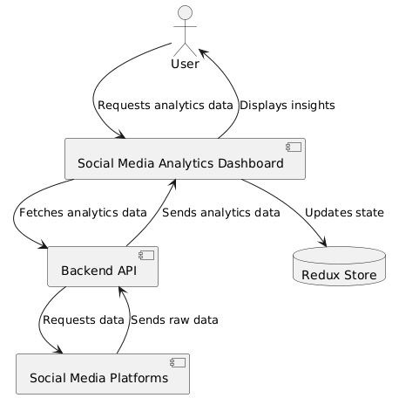

## Sequence Diagram

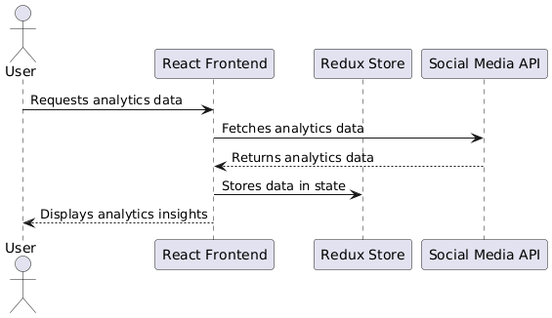

## 4.3 Activity Diagram

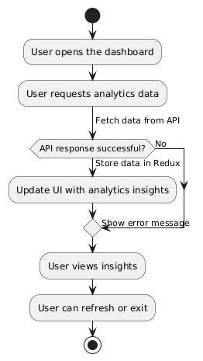

## State Diagram

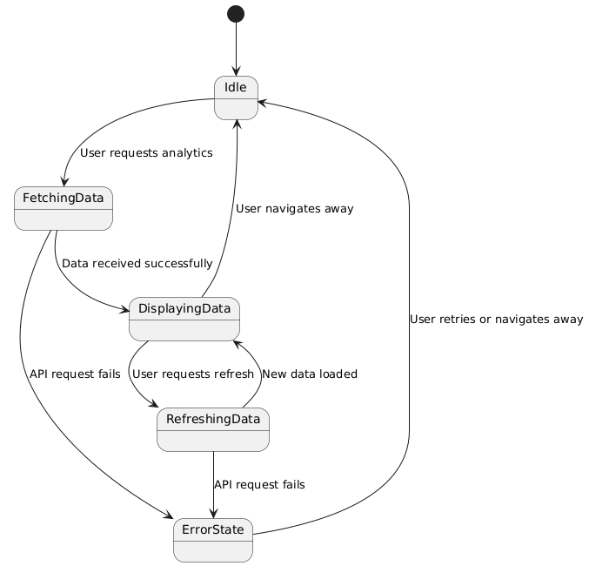

5.UI/UX Design & Prototyping

## Wireframes and Mock-ups

The final polished mock-up designed in FIGMA platform as follows:

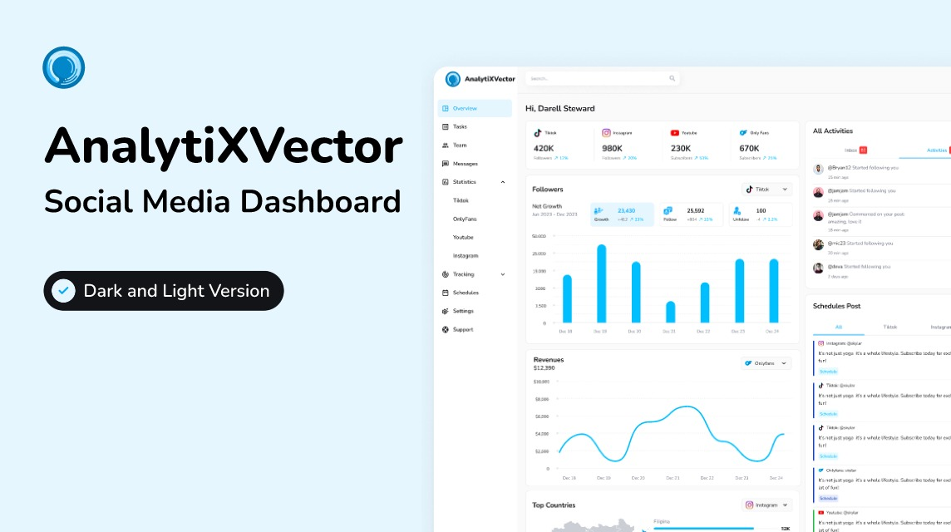

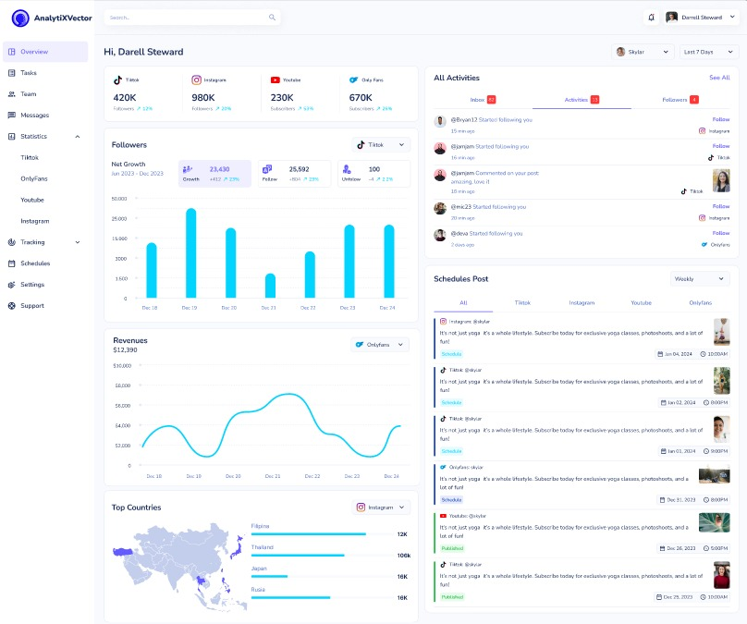

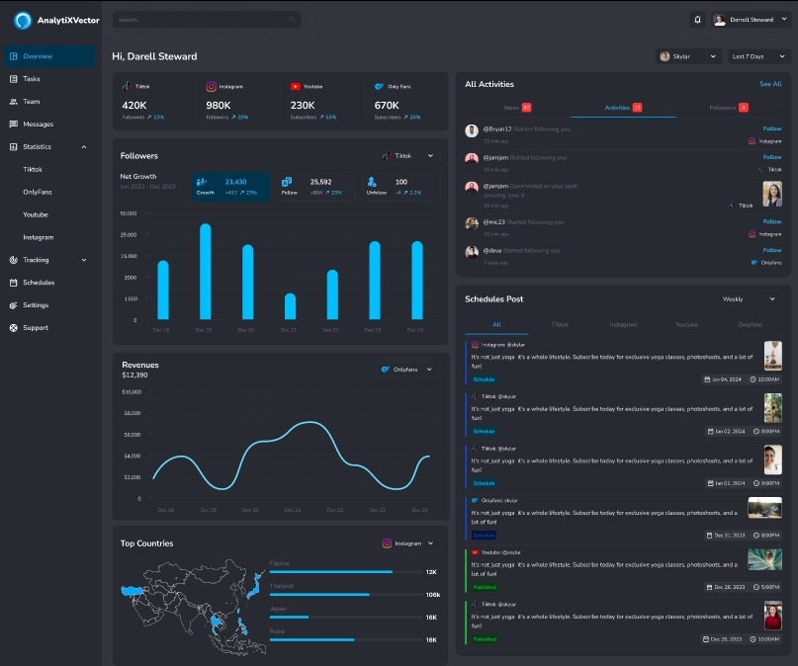

6. System Deployment & Integration

## 6.1. Technology Stack

Frontend:

* React.js (UI Framework)
* Redux (State Management)
* Axios or Fetch API (HTTP Requests)
* Material UI (UI Components)

Backend:

* External social media API (for fetching analytics data)

## 6.2. Deployment Diagram

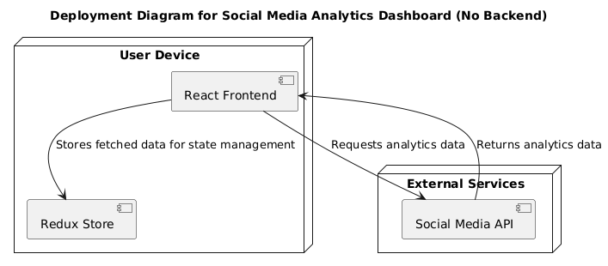

## 6.3. Component Diagram

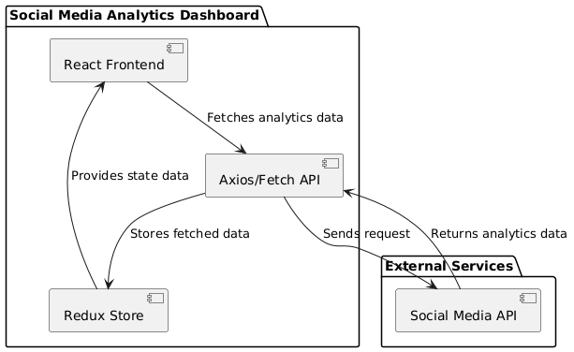

# Document Complete